**WEBSITE INFORMATION**

**This Website is about Online Examination on MCQ’s . In these we have implemented some features like, login and logout module. If user do not have any login, password or email user have to register the following information Selection of a subject here are 2 subjects like on java and English.Display MCQ Questions with 4 options for the answer.Here you can select options while giving test. It will show the result while you finish the test out of 100 .And it will give right and wrong answer in red line and green line.We have done this website in WordPress.**

**WordPress:**

**This WordPress site has been installed on a server running Apache version 2.0. It is a content management system used for designing website with minimal coding. The WordPress community is contributed with different plugins. So as to make designing website with WordPress easier and adding more functionality And it is install on server side.**

**The Plugins used with our sites are HD Quiz and force login. Easily hide your WordPress site from public viewing by requiring visitors to log in first as simple as flipping a switch Make your website private until it’s ready to share publicly, or keep it private for members only.**

**HD Quiz is very easy to use plugin to create an unlimited amount of quizzes and embed them onto any page or post. HD Quiz is equally perfect for building strong professional based questionnaires or fun Buzzfeed style Quizes.**

**Steps to be follow**

1. **Open the website link which I send to you.** [**abdulhannan.0fees.us/wp**](http://abdulhannan.0fees.us/wp) **this is the link**
2. **Then register the form In which there is a user and u have to give email for login and**

**password.**

1. **When you register go to login.**
2. **It will open the main page. Were you can see the information about topics.**
3. **Click on one topic. Which you want to give test.**
4. **Test time will be for half an hour. Questions are total 25 for both topics.**
5. **Attempts all questions then it will show the result after you finished.**
6. **It will give the marks and questions right and wrong in color line**
7. **That is green for right and red for wrong.**
8. **After that logout the Test.**

**ALL THE BEST**

**SCREENSHOTS**

**This is the login page**

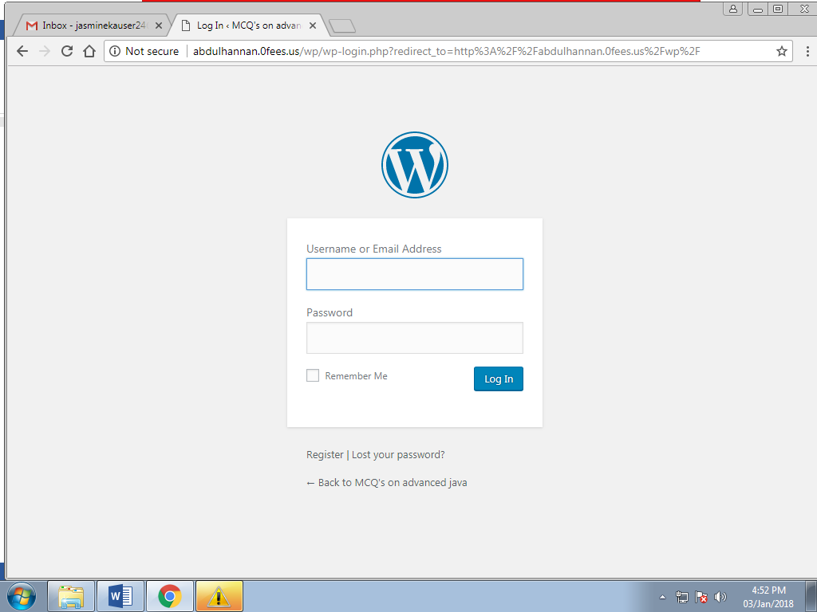

**If you do not have login id and password then register first from these**

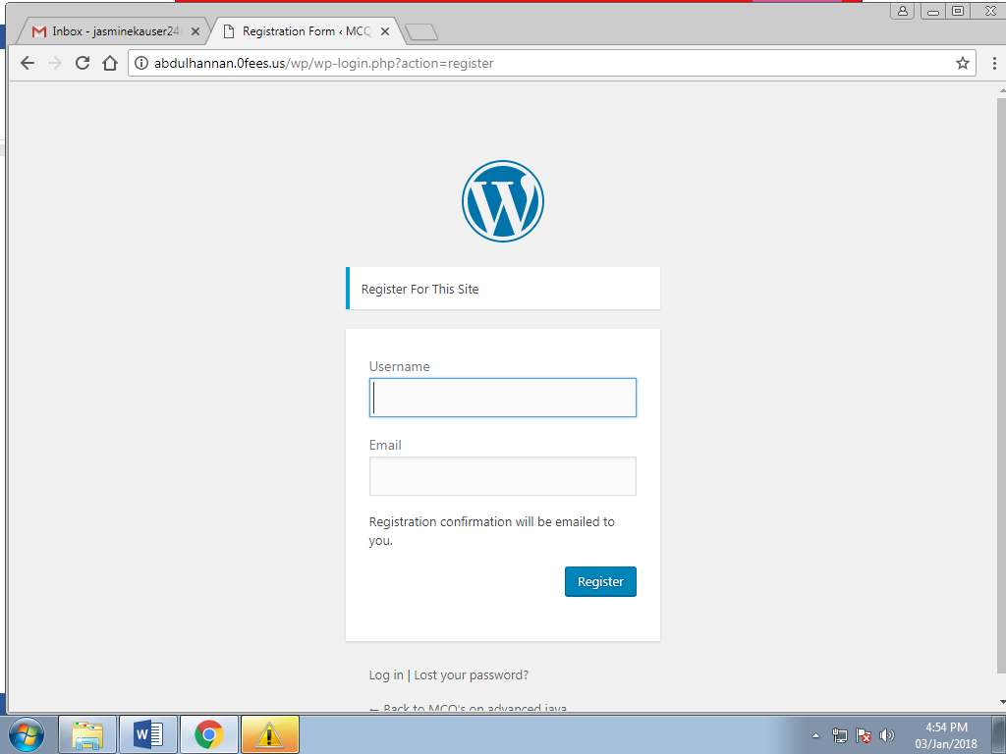

**When you login the first page you can see these**

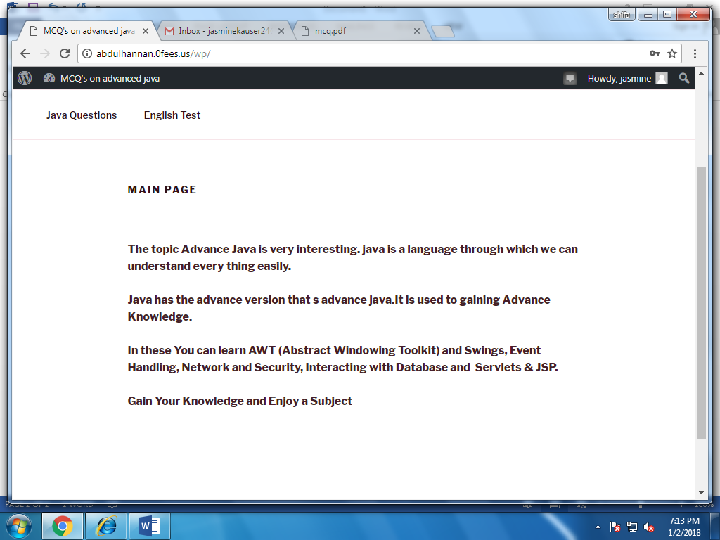

**Then select the topic on which you want to give the test here is java**

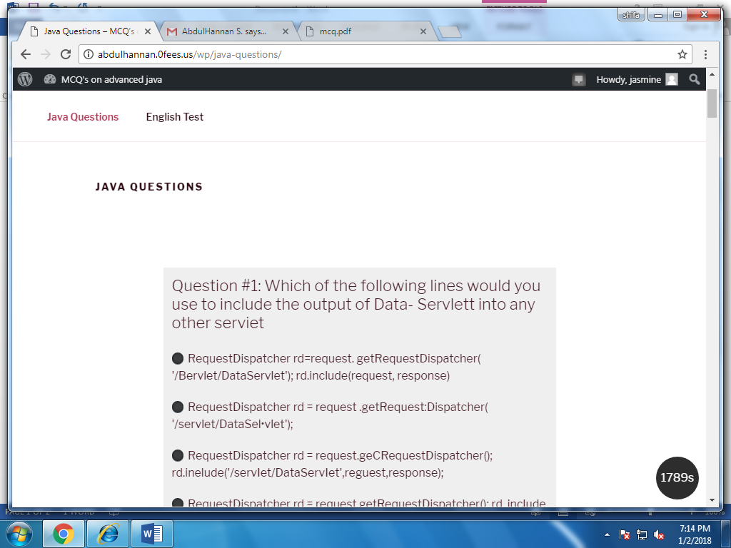

**Here you can see the multiple questions for java**

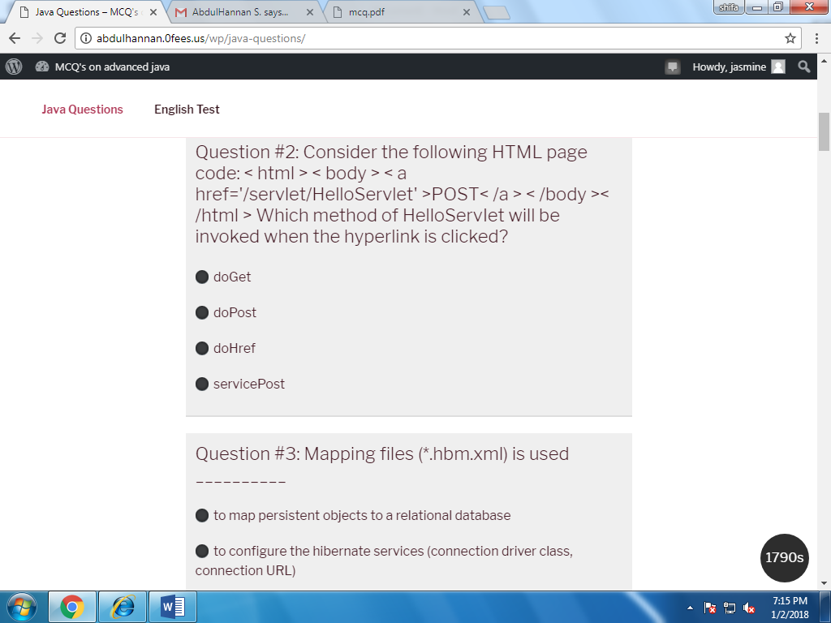

**Then here you can see the 2nd test that is English**

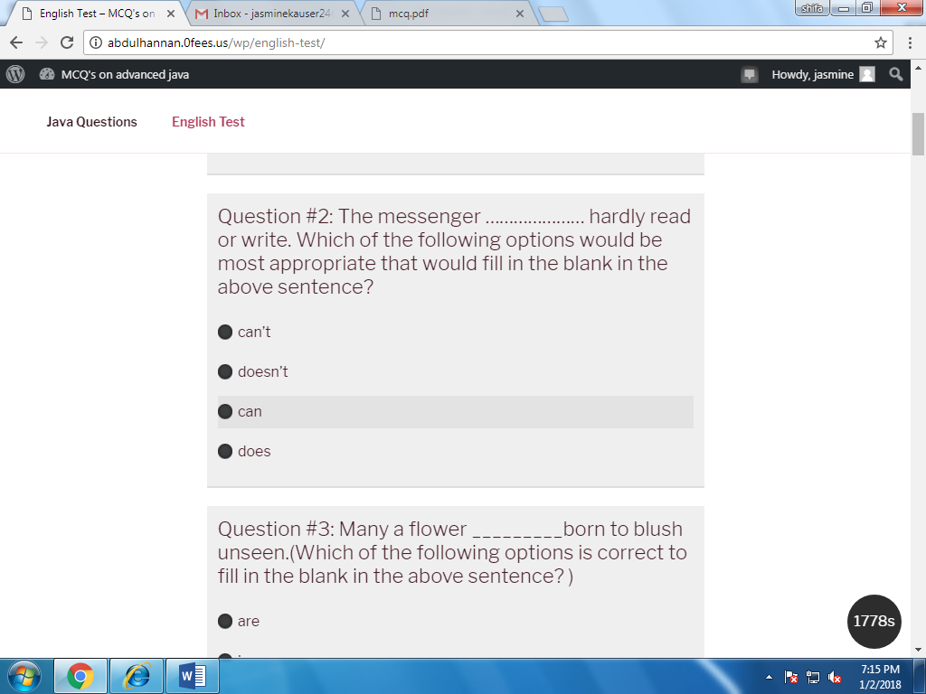

**Then here you can see the result how much you scored**

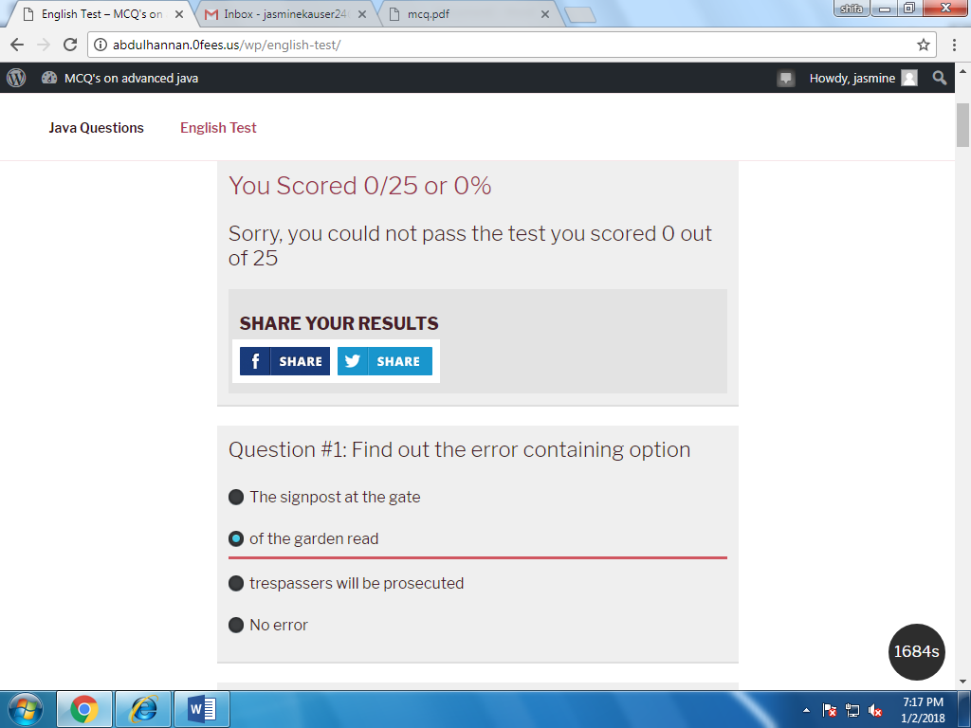

**Here you can see the right and wrong in colors**

**i.e. red for wrong and green for right.**

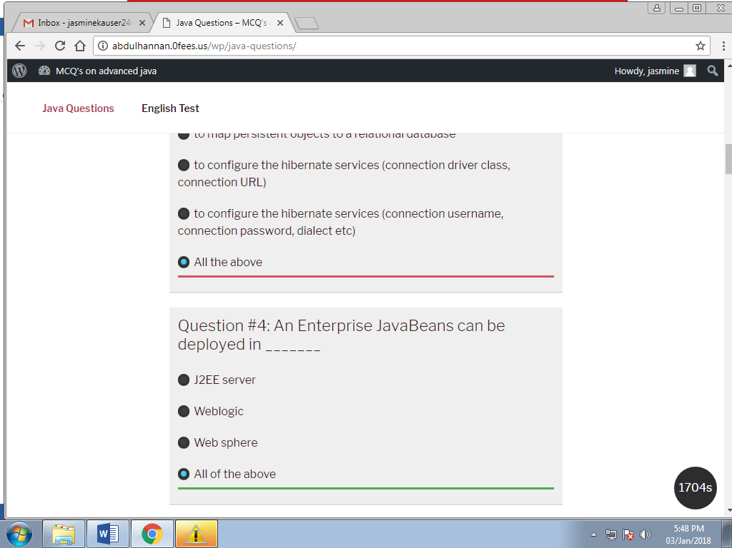

**Then Logout the Test**

